**1:Introduction**

* 1. **Background**

Long for people have been wanting something on the web that stores their personal data and information.Obviously there were services like dropbox and google drive,but looking at the feautures;they were more of backup/recovery system rather than a safe,secure environment where they can store their sensitive data.Hence,the idea of such a setup was always on my mind and finally in this project I came up with its implementation.

‘PrakharSafe’ is that type of a web service where all your sensitive videos,images,etc. can be saved securely on the web with a 3 level security.It also provides a ‘notes’ section which stores and displays all the important names/numbers that a person needs to remember in her/his daily life.



It includes some ultra modern features like *One Time Password* ,automated emails,etc.

Data recovery in case of a corruption is also possible.

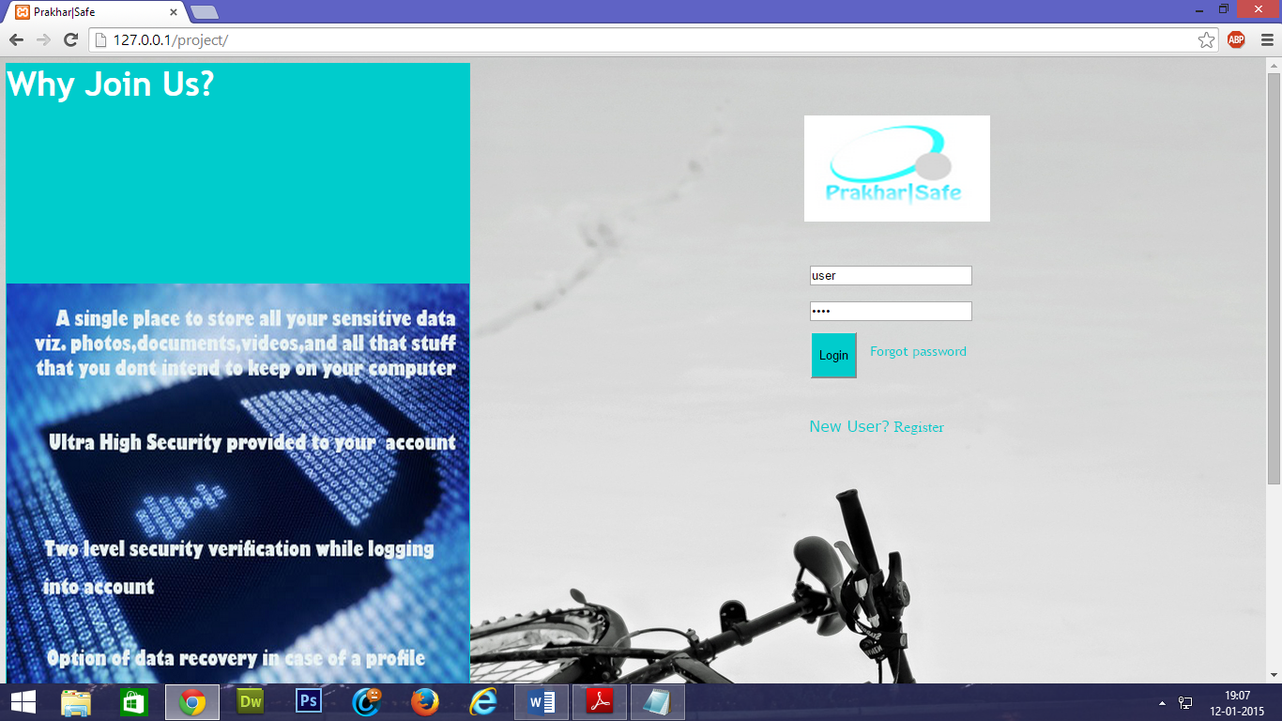

**1.2 PrakharSafe**

**Homepage**

**2: Requirement Analysis**

**2.1 Project Reqirements**

For the creation of this project,the foremost and basic requirement is that of a computer.Any properly installed popular operating system would do the job.A windows or Linux based OS would be ideal for the job as the required software for these programs is easily available.In order to create this service.

A LAN network needs to be established where the website will be visible/available.The scope of the website will depend on this LAN network.If an Ethernet connection with a static IP is obtained,the site can be published on the net.

The computer will being used will behave as a server.

A server client like Apache(derivatives),Windows 2012,etc. can be used to set up the server on a normal laptop machine.The version of this software will depend on the operating system on the machine.In my case,it was XAMPP(Apache).

The firewall needs to be configured in order to allow the services of the server(XAMPP).

There should be an installed database on the system in order to store the data/details of the user.In the case of the XAMPP,there is an already present MySQL database.

All beginers should try to use free software such as MySQL,etc.

The user should have a good & modern Internet Browser on her/his system in order to experience the website.Javascript should,preferentialy be switched ON on the browser.

Also,there should be Internet support on the local network,as many of the features(like OTP) will require an active data connection.

Also,the user should have an active e-mail ID in order to use the services of the website.

**3.2 Feasibility study**

This project,if implemented in the right direction can prove out to be a major hit;especially in today’s world.Nowadays everyone has some sort of data that they do not want the world to see and also do not want to save on their systems.This project has been developed keeping this in mind.

This can be majorly successful if we combine the applications and cloud this service on various platforms like smartphones and tablets.

The popularity will also develop on the further advancements that are made onto this project as this design is a very basic one and will need much modulation before being launched for general public.

**4:Methodology**

This will elaborately explain the step by step working of the engine:-

The first and foremost requirement is the presence of a Web Server on the machine intended to be used as a server.

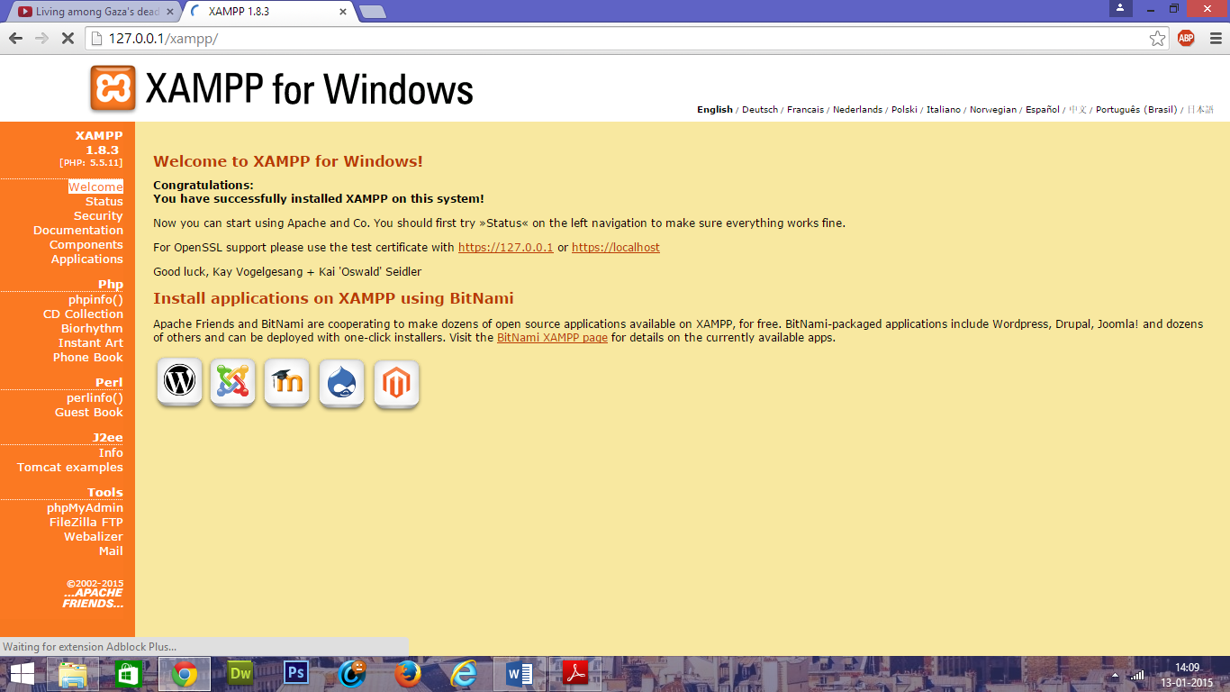

**A typical XAMPP Server**

*The controls for all features of the XAMPP server have to be switched On in order to use it optimally(usint Administrative properties.

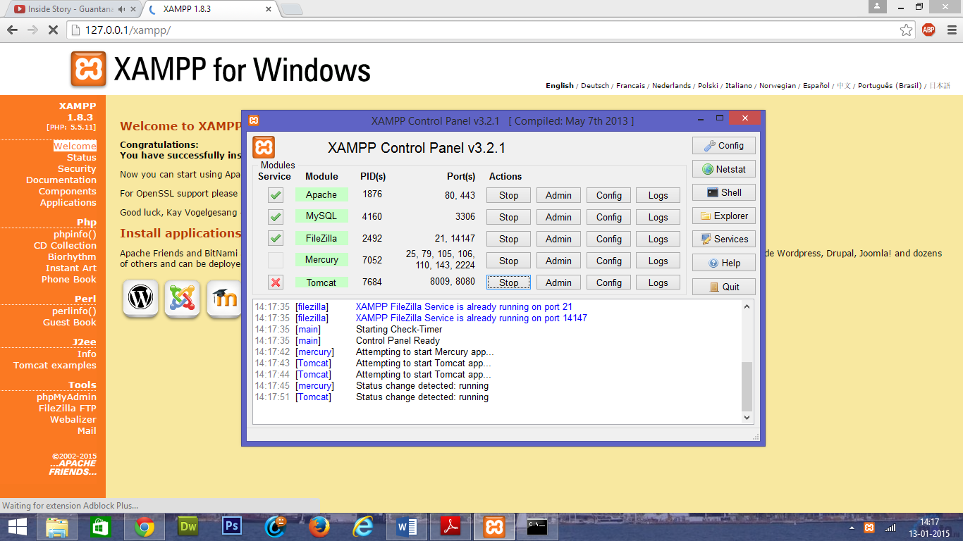

**XAMPP Control Panel**

The designer must have a database software installed in order to save,manipulate,display,etc. the various details.In this case it was a free,open-source software called “MySQL”.

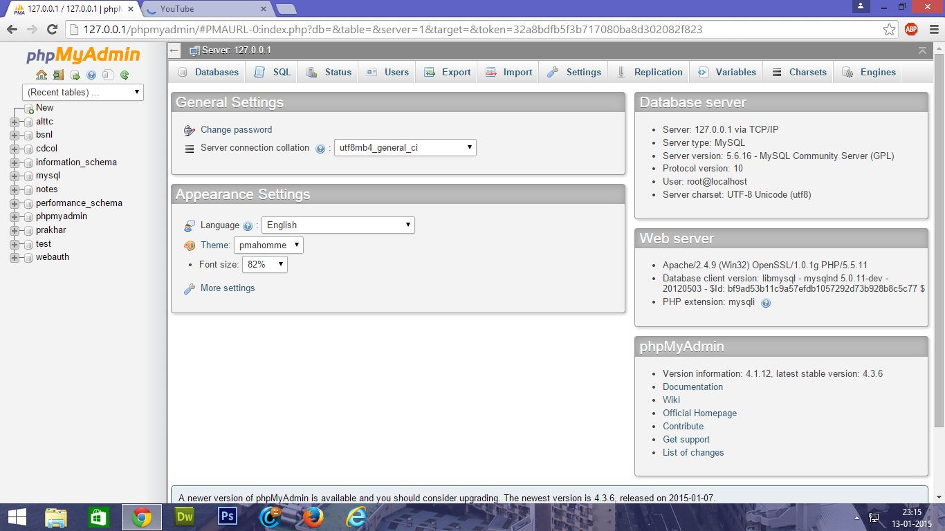

**MySQL Database**

The user then needs to go to the home page,supplying the IP Adress of the server/project on the browser URL Bar.The user will then be redirected to the home(index) page.



**‘PrakharSafe’ Home Page**

The user needs to be registered in order to sign in.If the user is not registered;the she/he needs to register by clicking on the ‘New User? Register’ option just below login.All details taken from the user are then fed into the MySQL table,with sensitive data like password being stored in an encrypted form.

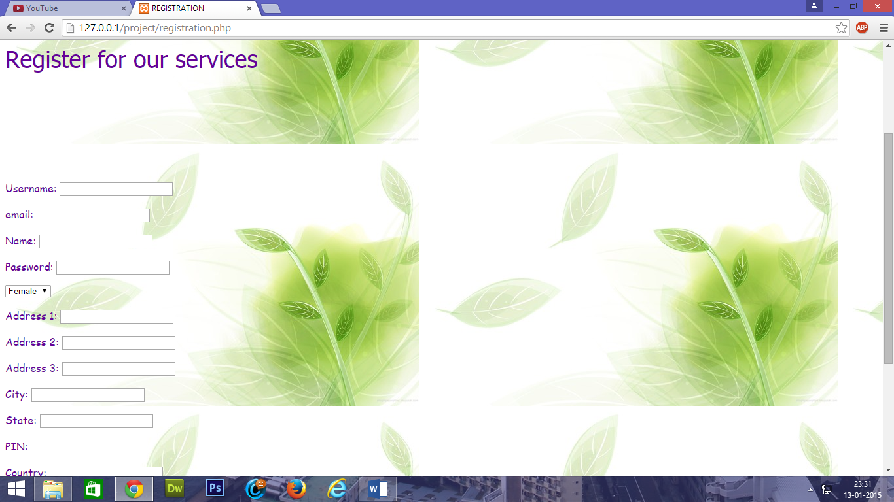

**General Registration Page**

The homepage also contains many other reference options like Terms, ‘Forgot Password’ ,etc. referring to the various pages of concern.

Once the user puts his/her username and password;the data is sent for verification & if it matches with the table data,then user is reditrected to the second level of security verification,i.e., OTP.

A system generated One Time Password is sent to the registered e-mail account & the user is redirected to the OTP verification page.If the OTP entered by the user matches with the code sent to the email,then the entry level security verification is complete & the user is directed to her/his home page & if there is a verification failure,then the session is destroyed and the user is logged out to the index page.

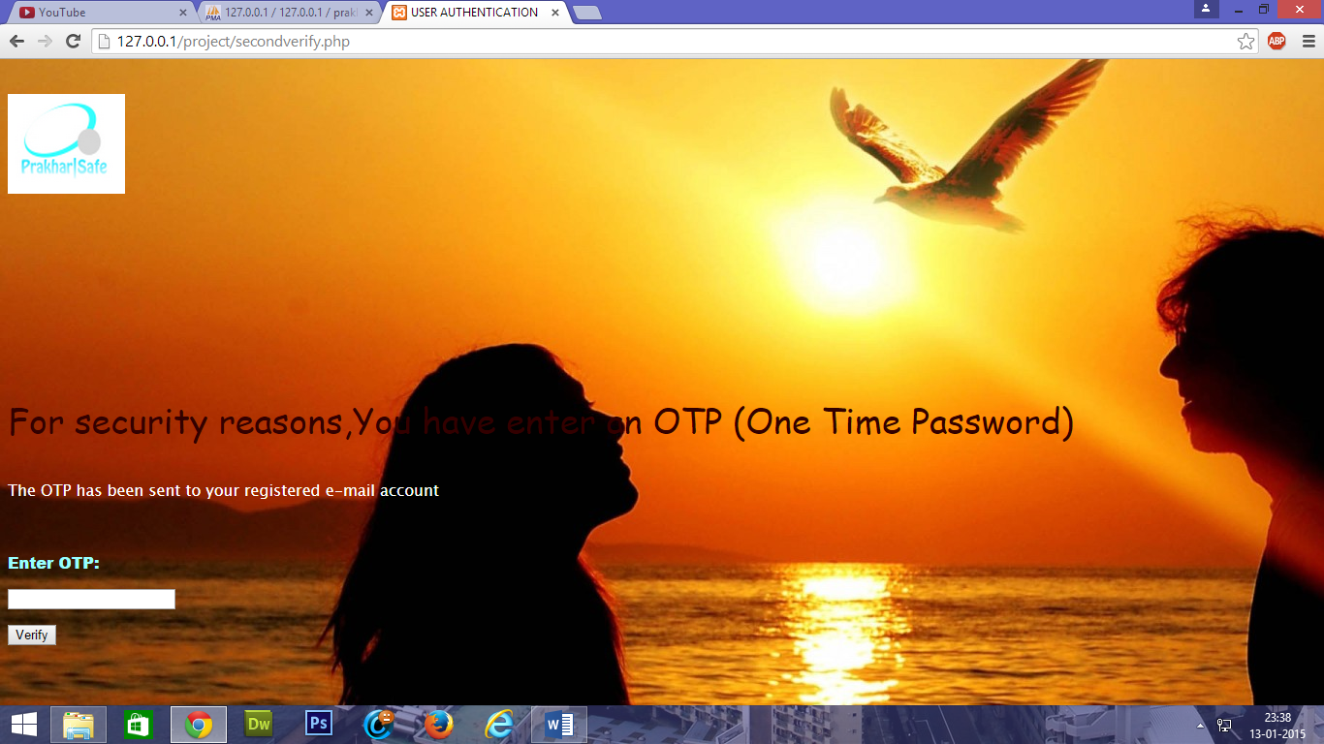

**OTP Verification Page**

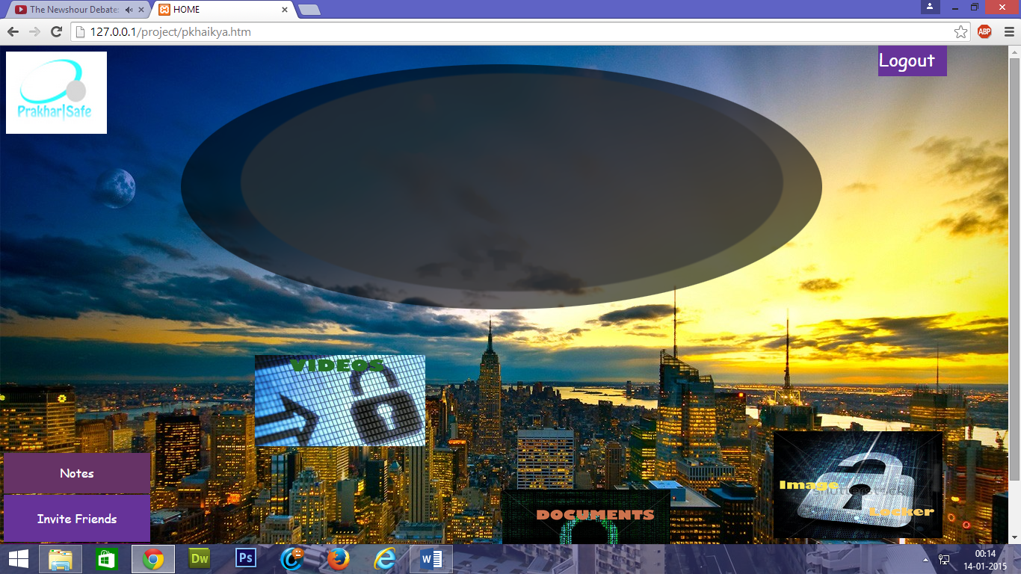

**HOME PAGE-I**

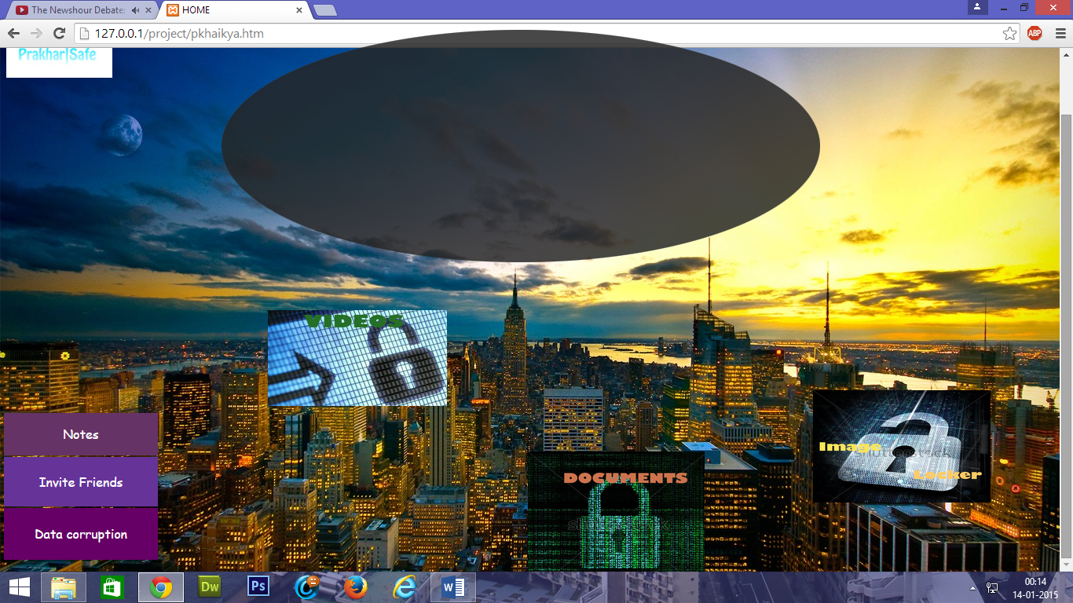

**HOME PAGE-II**

The session is started & the home-page displays a Welcome message to the user,fetching the name of the registered user from the database matching with that of the unique username,which is the primary key.

To the top right corner of the page,there is a logout option.Clicking on the ‘Logout’ option destroys the user session and redirects the user to the index page.

*The home interface gives you basically four features/options to use.These are:-

->Image Locker

->Documents Locker

->Video Locker

->Notes Section

Which are provided on the home-page in the form of different types of clickable options.

The Image,Documents & Videos locker are basically secure online drives where you can store your sensitive data in the respective forms.

The notes section is basically for storing important day to day data that is required to be memorised by us.This feature will definitely pick up pace once it is developed and launched for mobile platforms like android smartphones,tabs,etc.

For opening the pages pertaining to the various lockers,click on the specific locker that you want to open.For example,let us click on the images locker.Upon clicking,we are redirected to the third level of security verification where the user is asked to re-enter her/his password.

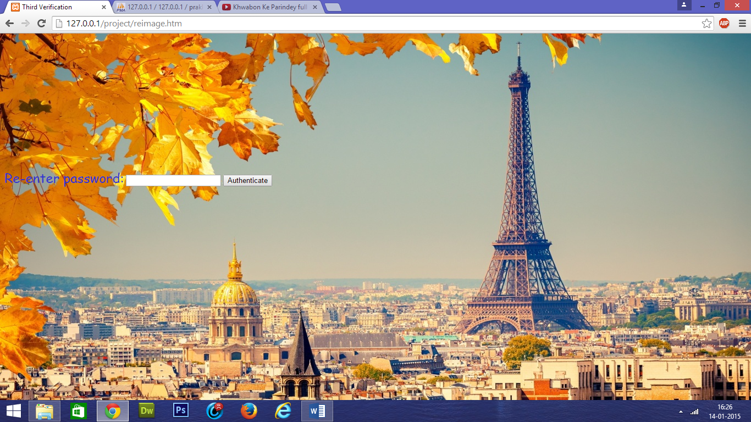

**‘Third Verification’ Page**

If the password is correct then the user is directed to the image locker,otherwise the session is destroyed and the user redirected to the site index page.

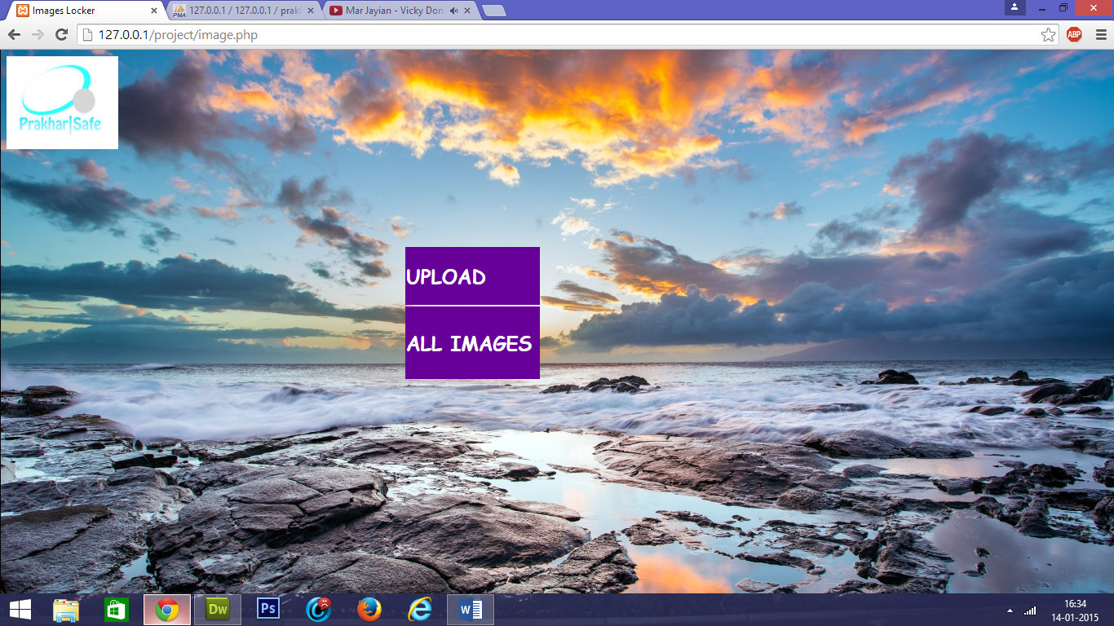

**Images Locker**

The main page pertaining to the images drive has basically 2 components viz. for Upload & Viewing of Documents. Clicking on the logo will redirect the user to the homepage.

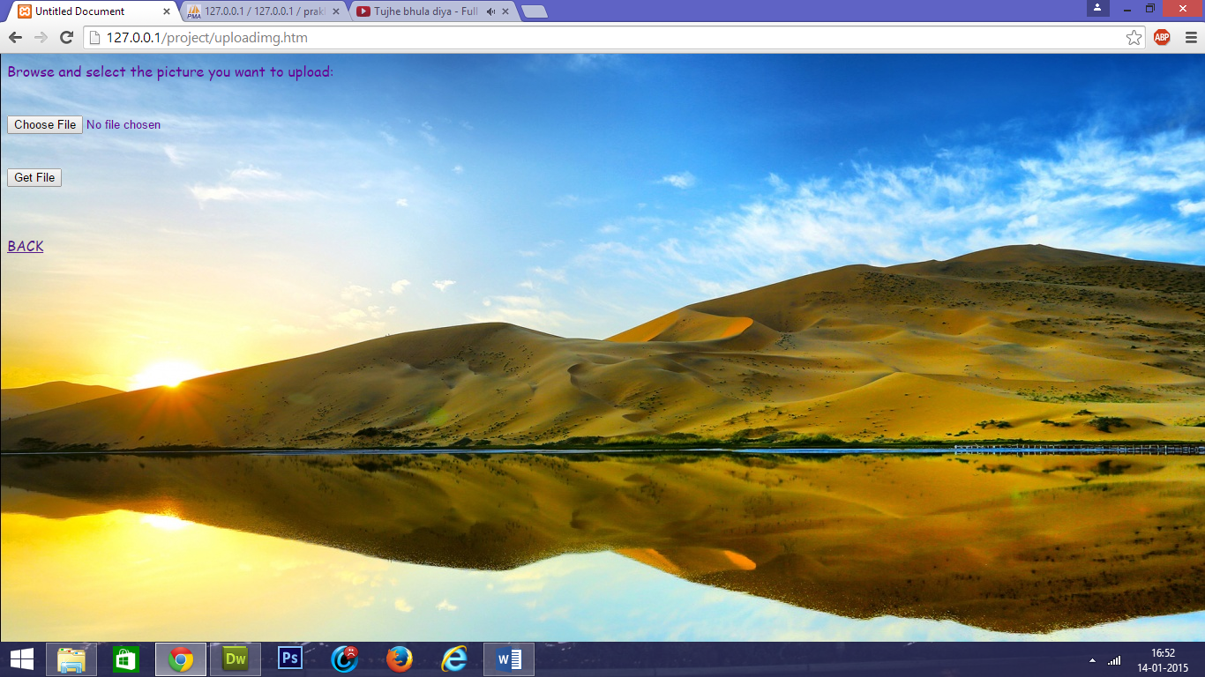

**Images Upload Page**

Clicking on the ‘Upload’ option redirects the user to the page where she/he can add images to the profile directory.The user has to select the file to be uploaded and click on ‘Get File’.Upon that,the image will be uploaded to the directory and the user will be redirected to the ‘Image locker’.

Clicking on ‘All Images leads the user to the page where all of his uploaded images are displayed and a link to open/download them exists.

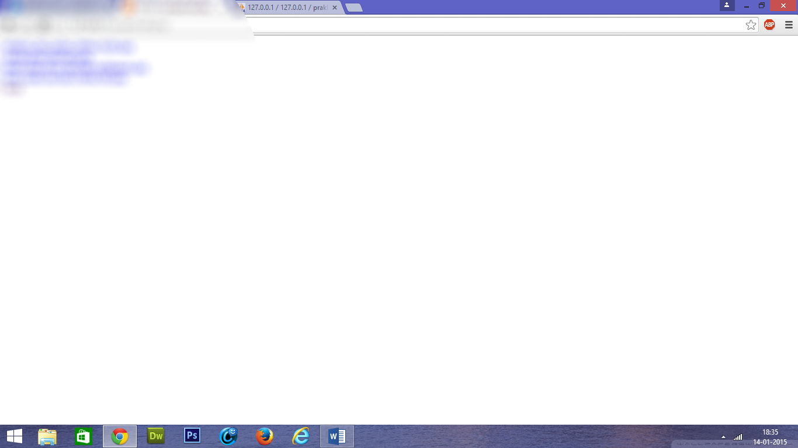

**The list of images displayed uploaded by the user**

**\*\*In the same way,the lockers for documents and videos have been designed.The following screenshorts give an illustrative idea.**

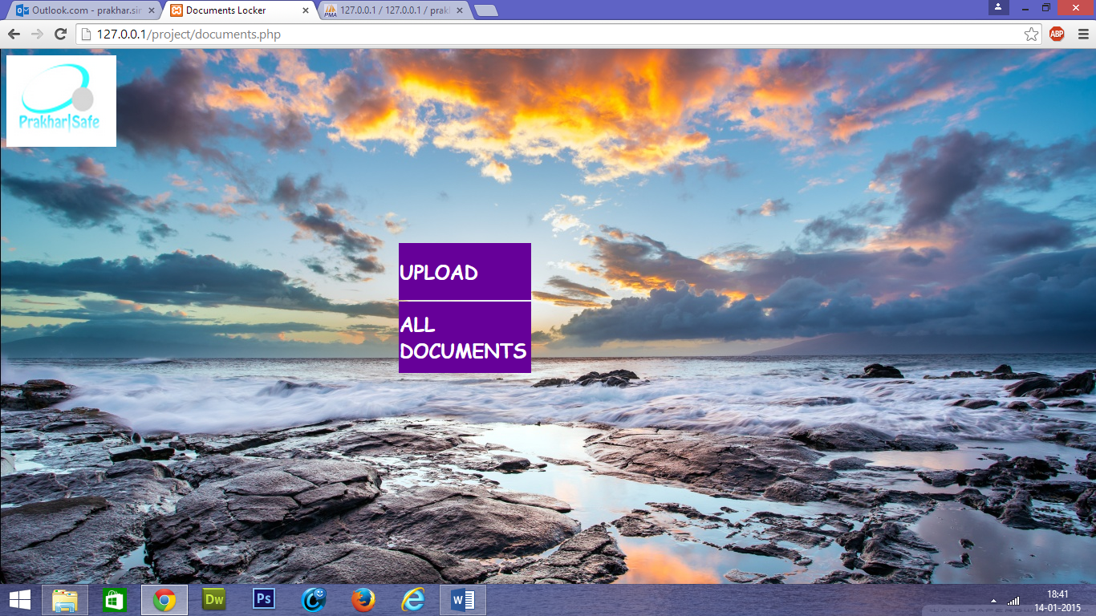

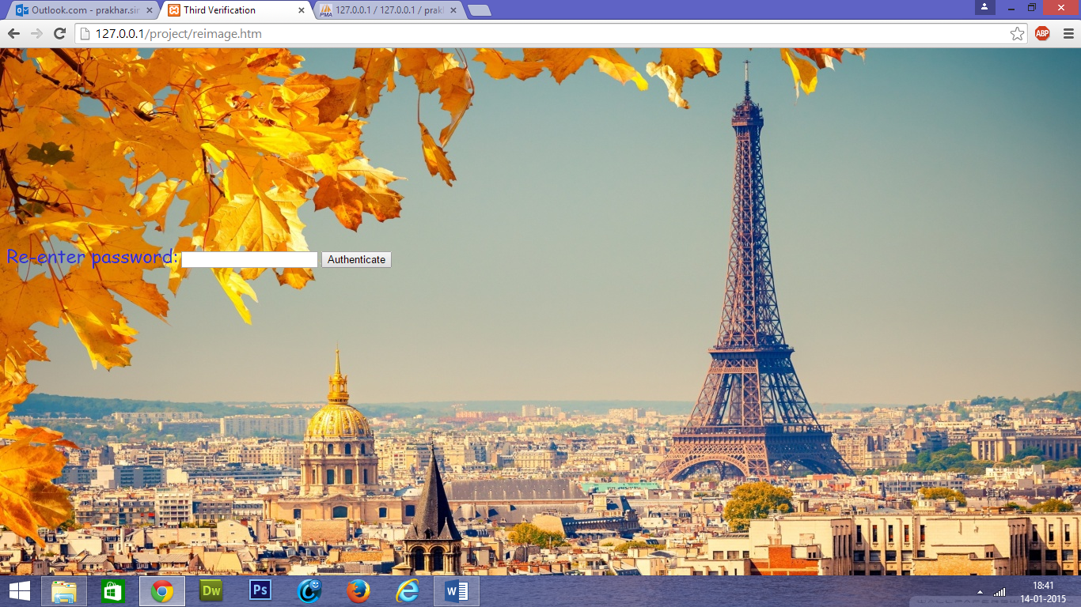

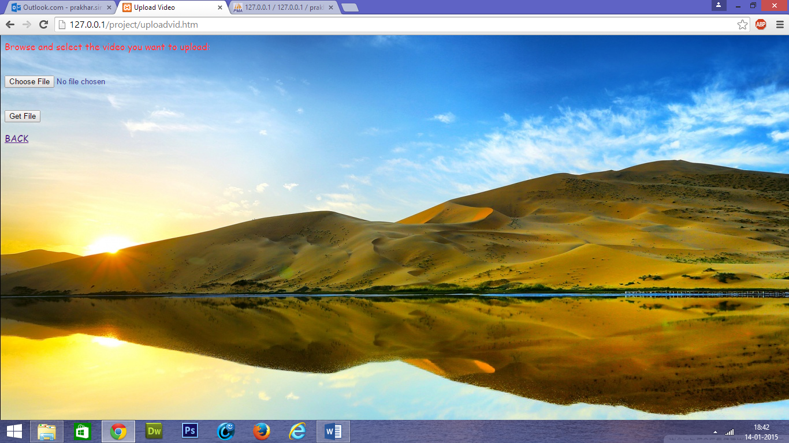

The project also has an attractive feature of notes,where the user can store all the data pertaining to the important numbers and text required in daily life like PAN,Aadhar,etc.

The notes section;however does not have a third level verification.

Below the list of notes,2 options(links) are given.One of them can be used to add more data to the table,while the other one is used to return to the homepage.

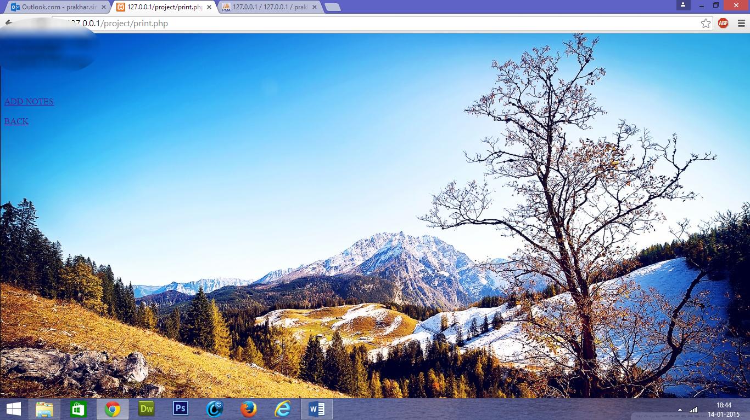

**The ‘Notes’ section**

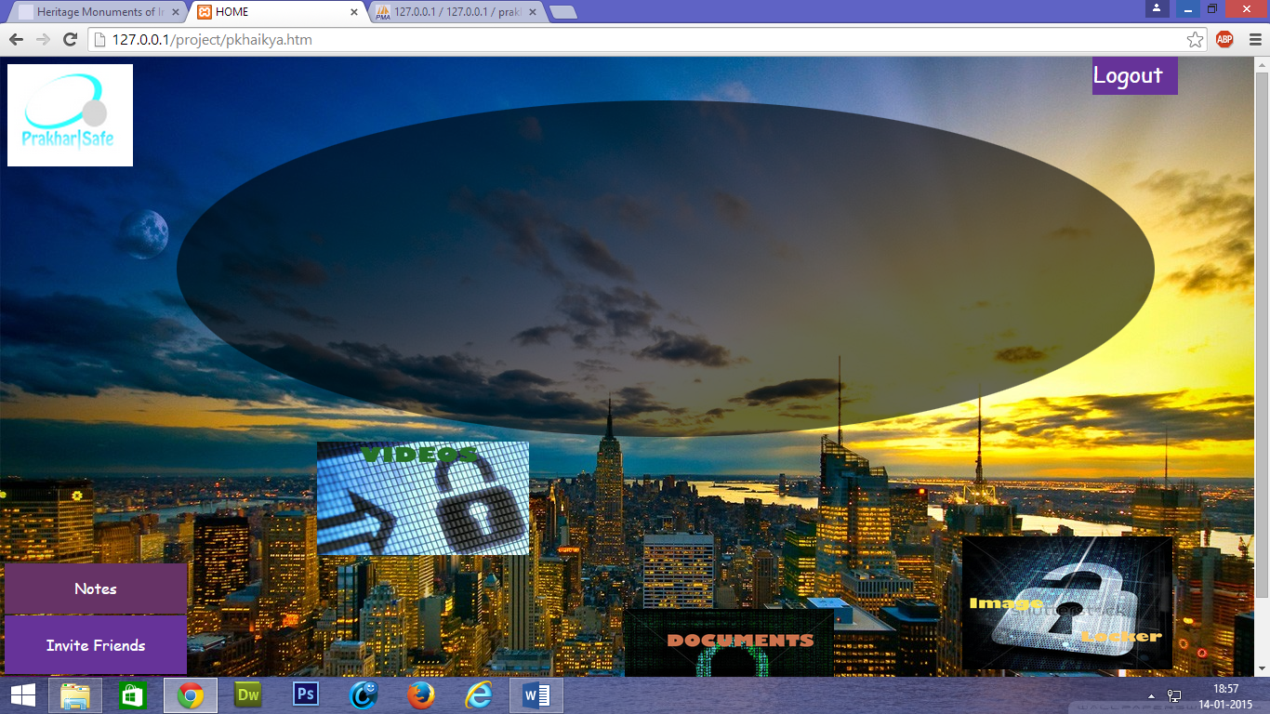

The homepage also contains the options of ‘Invite Friends’ & ‘Data Corruption.

->’Invite Friends’ accepts the e mail ID of a friend from the user and sends an automated mail to the third party informing her/him of the services offered by the website.

->’Data Corruption’ is linked to the same webpage as ‘Forgot Password’ & gives the user the option of contacting the Administrator directly as the Server has the backup of all the data pertaining to the user.

Finally,there is a ‘Logout’ option present for the user to end her/his session.Clciking on the option ends the session and redirects the user to the website’s index page.

**5.IMPLEMENTATION DETAILS**

**\*Partial,source-codeless details of implementation of the features associated**

**Registration:-**

There exists a HTML form containing headers with all the detais of the user.The contents of the form are submitted to a php file,which saves them into various variables and finally inserts them into the MySQL table.The username is the primary key in the database table.Upon successful registration,there is a unique folder created for the user in the database and a unique table in the MySQL database & user is directed to the index page for login.

**Login and Security Verification:-**

The user enters the username and passwlord for primary level of security.Then the browser is directed to a PHP page which fetches the registered email address of the user from the MySQL table and sends a system generated mail containing a High security password to the email account.Then the user is directed to an HTML form where she/he has to enter the required OTP/HSP and if it matches with that generated by the system,then a message is printed as ‘Login Success’ and the user is directed to the homepage after 3 seconds.,otherwise the session is destroyed and the user gets directed to the index page.

**General reference to the image,videos and documents locker:-**

The icons pertaining to images,videos and documents are basically linked to webpages that ask for the re-verification of password by a form.The entered data by the user is sent to a php page which verifies it with the data stored in the system & if it matches then a message is printed as ‘Authentication successful’ & user is redirected to the respective locker in 3 seconds or otherwise the session is destroyed and the it gets directed to the index page.

The ‘Upload’ page uses a PHP script to take the file to be uploaded from the user and sends it to the server directory and it is redirected to the specific locker page.

The option of ‘All Images/Documents/Videos’ uses a PHP script to display and create links to all the files previously uploaded by the user.

The ‘Notes’ section displays the contents of a 2-column unique table from the SQL database that was created specifically for the user upon registration.To add elements to the table,the user is redirected to another HTML form,where she/he has to enter the Note details.The form sends the data to a PHP page,which inserts the accepted data into a unique table of the MySQL database and redisplays its contents.

The ‘Invite Friends’ option accepts the email ID of a friend of the user and sends her/him the link to the services provided.

Finally,when the user clicks on the ‘Logout’ option,she/he is redirected to a php page,which first destroys the session & the session variables,and then sends the user to the index page.

*Pages like ‘Terms’, ‘Contact’ are basic HTML pages containing basic text.

**6.RESULTS,CONCLUSIONS AND FUTURE DEVELOPMENT:-**

This mini project is something very basic in an idea that has been pertaining in my mind for a long time.This idea,if developed further can be boon for modern lifestyle in this age where everybody has data that they neither want to share with the world,nor want to save on their system/phones.This is the perfect solution to the large amount of sensitive data that a person in this slain world wants to hide from others.The major success of this product will lie in making it handy.If the service is made available available handy in android smartphones/tablets,then it has the potential to be a major success at the highest level.

Most of the handy devices at this time have web access 24x7 and and as web connectivity will not be a hinderance in the future,and hence; future prospects for a project like this has high potential.

**SOME OTHER SCREENSHOTS DISPLAYING THE WORKING OF THE PROJECT:**

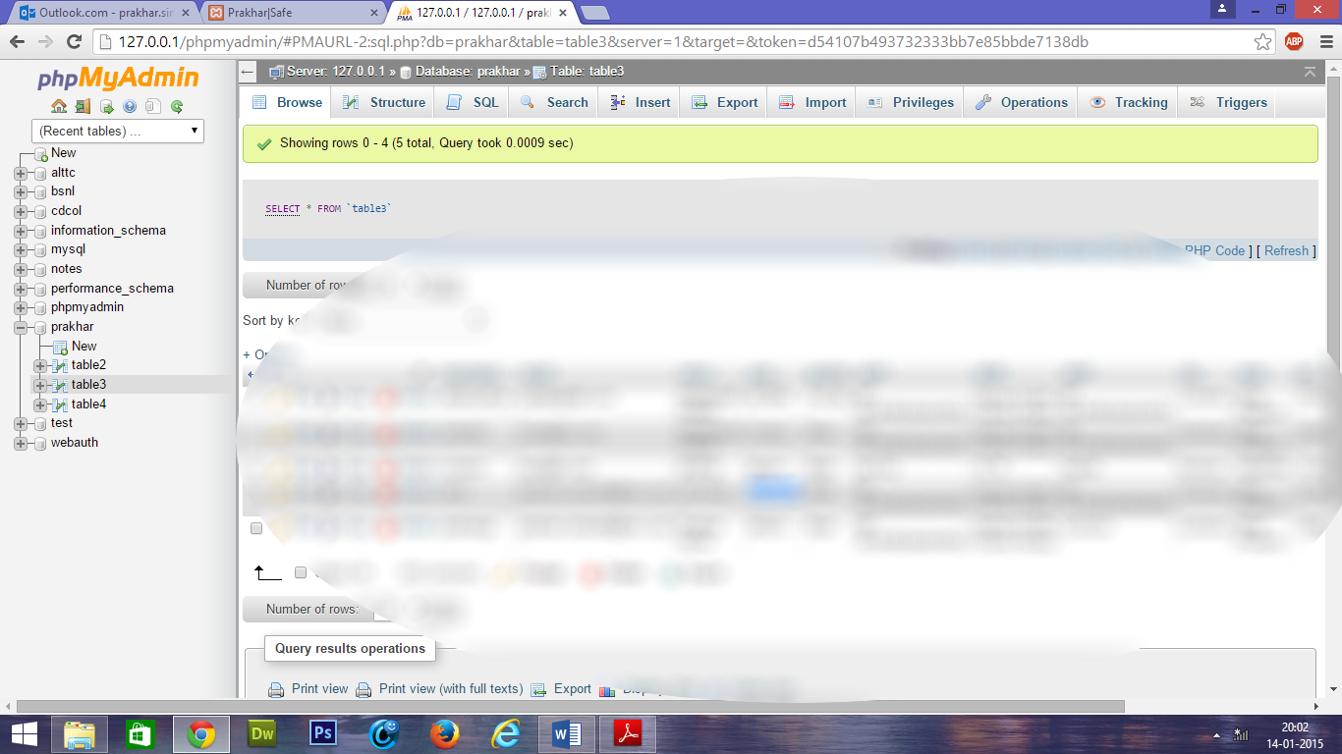

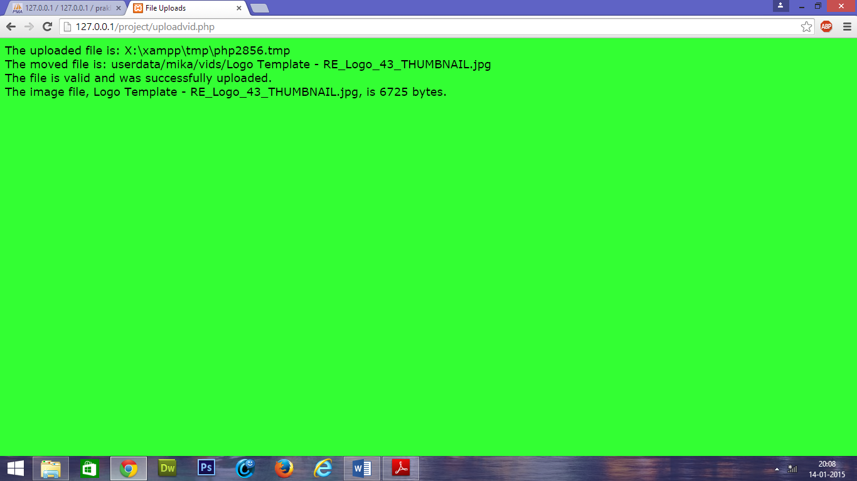

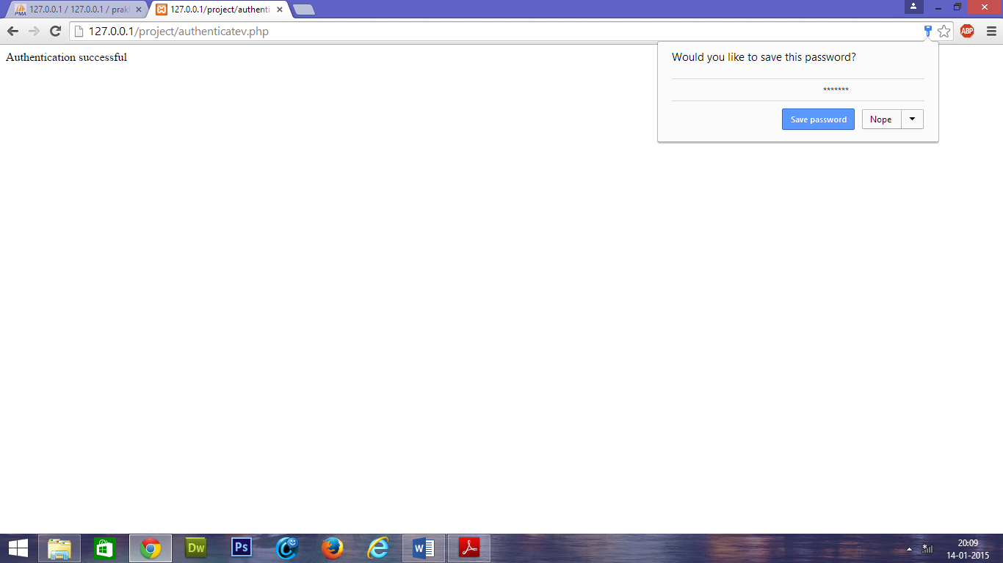

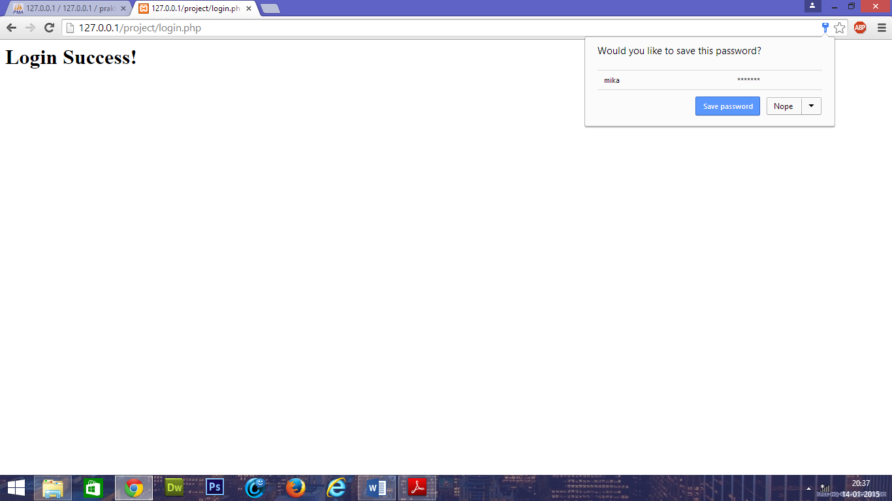

**CERTIFICATE OF APPROVAL**

The undersigned certify that the mini-project entitled “High Security Locker” submitted by Prakhar Sinha to Advance Level Telecom Training Centre (BSNL),Ghaziabad in partial fulfilment of requirement for Winter Training (Web Development),2014. The project was carried out under special supervision and within the time frame prescribed by the syllabus.

We found the student to be hardworking, skilled, bonafide and ready to undertake any commercial and industrial work related to their field of study.

**ACKNOWLEDGEMENT**

We take this opportunity to express my deepest and sincere gratitude to our supervisor for his/her insightful advice, motivating suggestions, invaluable guidance, help and support in successful completion of this project and also for his/her constant encouragement and advice throughout the programme.

We express our deep gratitude to for his/her/their regular support, co-operation, and co-ordination.

The in-time facilities provided by the centre throughout the Training program are also equally acknowledgeable.

We would like to convey our thanks to the teaching and non teaching staff of the IT Department(ALTTC,Ghaziabad), acem for their invaluable help and support throughout the period of Training Programme. I am also grateful to all our batchmates for their help, encouragement and invaluable suggestions.

Finally, yet more importantly, I would like to express my deep appreciation to my family for their perpetual support and encouragement throughout the Training period.

References:-

*www.w3schools.com

# *PHP: The Complete Reference by Steven Holzner

## [*The Joy Of PHP: A Beginner's Guide To Programming Interactive Web Applications With PHP And MySQL](http://www.amazon.com/dp/B00BALXN70?tag=best-php-book-20" \o "The Joy of PHP: A Beginner's Guide to Programming Interactive Web Applications with PHP and mySQL)

## [*PHP Solutions: Dynamic Web Design Made Easy by David Powers](http://www.amazon.com/dp/1430232498?tag=best-php-book-20" \o "PHP Solutions: Dynamic Web Design Made Easy)

**[DECLARATION](http://www.amazon.com/dp/B00BALXN70?tag=best-php-book-20" \o "The Joy of PHP: A Beginner's Guide to Programming Interactive Web Applications with PHP and mySQL)**

[I, Prakhar Sinha](http://www.amazon.com/dp/B00BALXN70?tag=best-php-book-20" \o "The Joy of PHP: A Beginner's Guide to Programming Interactive Web Applications with PHP and mySQL)**[,](http://www.amazon.com/dp/B00BALXN70?tag=best-php-book-20" \o "The Joy of PHP: A Beginner's Guide to Programming Interactive Web Applications with PHP and mySQL)**[of ‘National Institute of Technology](http://www.amazon.com/dp/B00BALXN70?tag=best-php-book-20" \o "The Joy of PHP: A Beginner's Guide to Programming Interactive Web Applications with PHP and mySQL)**[, Durgapur](http://www.amazon.com/dp/B00BALXN70?tag=best-php-book-20" \o "The Joy of PHP: A Beginner's Guide to Programming Interactive Web Applications with PHP and mySQL)**[,](http://www.amazon.com/dp/B00BALXN70?tag=best-php-book-20" \o "The Joy of PHP: A Beginner's Guide to Programming Interactive Web Applications with PHP and mySQL)[of Information Technology[Semester IV] hereby declare that I have completed my project, titled](http://www.amazon.com/dp/B00BALXN70?tag=best-php-book-20" \o "The Joy of PHP: A Beginner's Guide to Programming Interactive Web Applications with PHP and mySQL)**[‘High Security Online Locker’.](http://www.amazon.com/dp/B00BALXN70?tag=best-php-book-20" \o "The Joy of PHP: A Beginner's Guide to Programming Interactive Web Applications with PHP and mySQL)**[The information submitted herein is true and original to the best of my knowledge.](http://www.amazon.com/dp/B00BALXN70?tag=best-php-book-20" \o "The Joy of PHP: A Beginner's Guide to Programming Interactive Web Applications with PHP and mySQL)

[Date:](http://www.amazon.com/dp/B00BALXN70?tag=best-php-book-20" \o "The Joy of PHP: A Beginner's Guide to Programming Interactive Web Applications with PHP and mySQL)

[Place:](http://www.amazon.com/dp/B00BALXN70?tag=best-php-book-20" \o "The Joy of PHP: A Beginner's Guide to Programming Interactive Web Applications with PHP and mySQL)

[Signature](http://www.amazon.com/dp/B00BALXN70?tag=best-php-book-20" \o "The Joy of PHP: A Beginner's Guide to Programming Interactive Web Applications with PHP and mySQL)